**Threading with Monitor**

A monitor is a mechanism for ensuring that only one thread at a time may be running a certain piece of code (critical section). A monitor has a lock, and only one thread at a time may acquire it. To run in certain blocks of code, a thread must have acquired the monitor. A monitor is always associated with a specific object and cannot be dissociated from or replaced within that object.

**Monitor has the following features:**

* It is associated with an object on demand.
* It is unbound, which means it can be called directly from any context.
* An instance of the Monitor class cannot be created.

**The following information is maintained for each synchronized object:**

* A reference to the thread that currently holds the lock.
* A reference to a ready queue, which contains the threads that are ready to obtain the lock.
* A reference to a waiting queue, which contains the threads that are waiting for notification of a change in the state of the locked object.

**Monitor Class**

The Monitor Class Provides a mechanism that synchronizes access to objects. The Monitor class is a collection of static methods that provides access to the monitor associated with a particular object, which is specified through the method's first argument. the class provide following method.

* Monitor.Enter() : Acquires an exclusive lock on the specified object. This action also marks the beginning of a critical section.
* Monitor.Exit() : Releases an exclusive lock on the specified object. This action also marks the end of a critical section protected by the locked                          object.
* Monitor.Pules() : Notifies a thread in the waiting queue of a change in the locked object's state.
* Monitor.Wait() : Releases the lock on an object and blocks the current thread until it reacquires the lock.
* Monitor.PulesAll() : Notifies all waiting threads of a change in the object's state.
* Monitor.TryEnter() : Attempts to acquire an exclusive lock on the specified object.

In the following example we have three threads which are trying to write a file (akshay.txt). Basically each thread will wait until the locker object gets released by the first thread that achieved a lock, before it attempts to write to our file.

using System;  
using System.IO;  
using System.Threading;  
namespace monitorclass  
{  
class Program  
    {  
        static object locker = new object();  
        static void ThreadMain()  
        {            
             Thread.Sleep(800);    // Simulate Some work  
             WriteToFile();          // Access a shared resource / critical section  
        }  
        static void WriteToFile()  
        {  
            String ThreadName = Thread.CurrentThread.Name;  
            Console.WriteLine("{0} using C-sharpcorner.com", ThreadName);  
            Monitor.Enter(locker);  
            try

            {  
                using (StreamWriter sw = new StreamWriter(@"D:\akshaydata\akshay.txt", true))  
               {  
                    sw.WriteLine(ThreadName);  
                }  
            }  
            catch (Exception ex)  
            {  
                Console.WriteLine(ex.Message);  
            }  
            finally  
            {  
                Monitor.Exit(locker);  
                Console.WriteLine("{0} releasing C-sharpcorner.com", ThreadName);  
            }  
        }  
        static void Main(string[] args)  
        {  
            for (int i = 0; i < 3; i++)

            {  
                Thread thread = new Thread(new ThreadStart(ThreadMain));  
                thread.Name = String.Concat("Thread - ", i);  
                thread.Start();  
                  
            }  
            Console.Read();  
        }  
    }  
}

**Output**

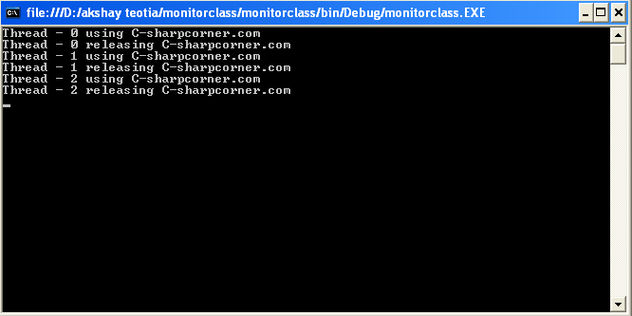

**Use Wait() and Pulse() to create a ticking clock**

Monitor.Wait() is used to  Releases the lock on an object in order to permit other threads to lock and access the object. The calling thread waits while another thread accesses the object. Pulse signals are used to notify waiting threads about changes to an object's state.

using System;  
using System.Threading;  
namespace waitndpulesmethod  
{  
class TickTock  
    {  
        public void tick(bool running)  
        {  
            lock (this)  
            {  
                if (!running)  
                {  //  stop  the  clock      
                    Monitor.Pulse(this);  //  notify  any  waiting  threads      
                    return;  
                }  
                Console.Write("Tick  ");  
                Monitor.Pulse(this);  //  let  tock()  run      
                Monitor.Wait(this);  //  wait  for  tock()  to  complete      
            }  
        }  
        public void tock(bool running)  
        {  
            lock (this)  
            {  
                if (!running)  
                {  //  stop  the  clock      
                    Monitor.Pulse(this);  //  notify  any  waiting  threads    |  
                    return;  
                }  
                Console.WriteLine("Tock");  
                Monitor.Pulse(this);  //  let  tick()  run      
                Monitor.Wait(this);  //  wait  for  tick()  to  complete      
            }  
        }  
    }  
    class MyThread  
    {  
        public Thread thrd;  
        TickTock ttOb;  
        //  Construct  a  new  thread.      
        public MyThread(string name, TickTock tt)  
        {  
            thrd = new Thread(this.run);  
            ttOb = tt;  
            thrd.Name = name;  
            thrd.Start();  
        }  
        //  Begin  execution  of  new  thread.      
        void run()  
        {  
            if (thrd.Name == "Tick")  
            {  
                for (int i = 0; i < 5; i++) ttOb.tick(true);  
                ttOb.tick(false);  
            }  
            else  
            {  
                for (int i = 0; i < 5; i++) ttOb.tock(true);  
                ttOb.tock(false);  
            }  
        }  
    }  
    class TickingClock  
    {  
        public static void Main()  
        {  
            TickTock tt = new TickTock();  
            MyThread mt1 = new MyThread("Tick", tt);  
            MyThread mt2 = new MyThread("Tock", tt);  
   
            mt1.thrd.Join();  
            mt2.thrd.Join();  
            Console.WriteLine("Clock  Stopped");  
            Console.Read();  
        }  
    }    
}

**Output**

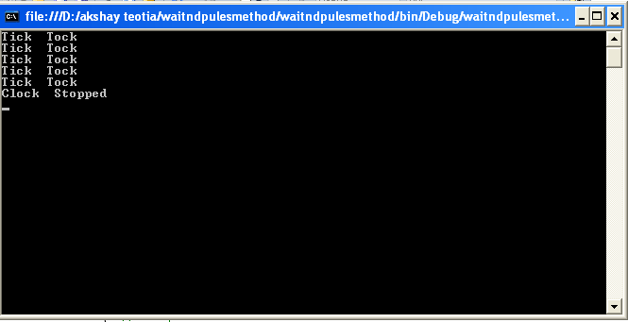

**Monitor Pool**

A thread pool is a collection of threads that can be used to perform a number of tasks in the background. Thread pools are often employed in server applications. Each incoming request is assigned to a thread from the thread pool. Once a thread in the pool completes its task, it is returned to a queue of waiting threads, where it can be reused. This reuse enables applications to avoid the cost of creating a new thread for each task.

using System;  
using System.Threading;  
namespace monitorpool  
{  
class Akshay  
    {  
        private const int threads = 3;  
        private const int workitems = 20;  
        private static Object locker = new Object();  
        static void Worker()  
        {  
            while (true)  
            {  
                lock (locker)  
                {  
                    Monitor.Wait(locker);  
                }  
                System.Console.WriteLine("{0} access the website c-sharpcorner", Thread.CurrentThread.Name);  
                Thread.Sleep(100);  
           }  
        }  
        [STAThread]  
        static void Main(string[] args)  
        {  
           Thread[] t = new Thread[threads];  
             for (int k = 0; k < threads; k++)  
            {  
               t[k] = new Thread(new ThreadStart(Worker));  
                t[k].Name = "user " + k;  
                t[k].IsBackground = true;  
                t[k].Start();  
            }  
            for (int i = 0; i < workitems; i++)  
            {  
               Thread.Sleep(1000);  
                 lock (locker)  
                {  
                    Monitor.Pulse(locker);  
                }  
            }  
            Console.Read();  
        }  
    }  
}

**Output**

